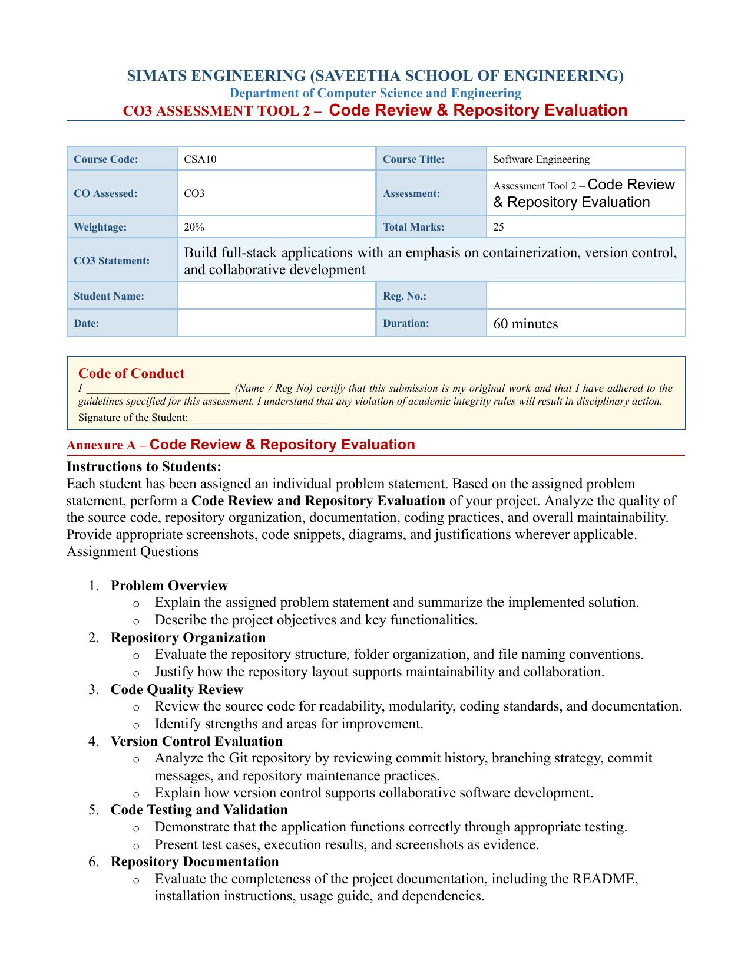

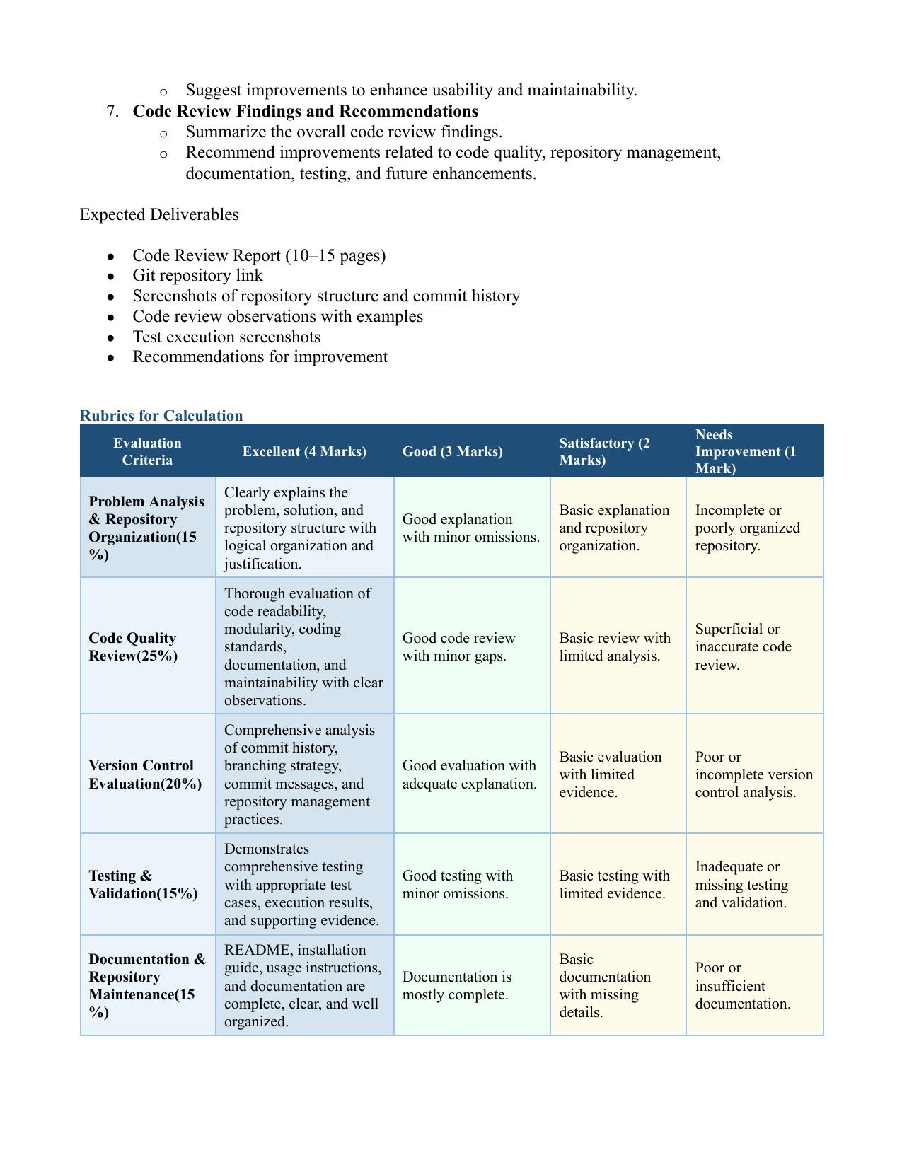

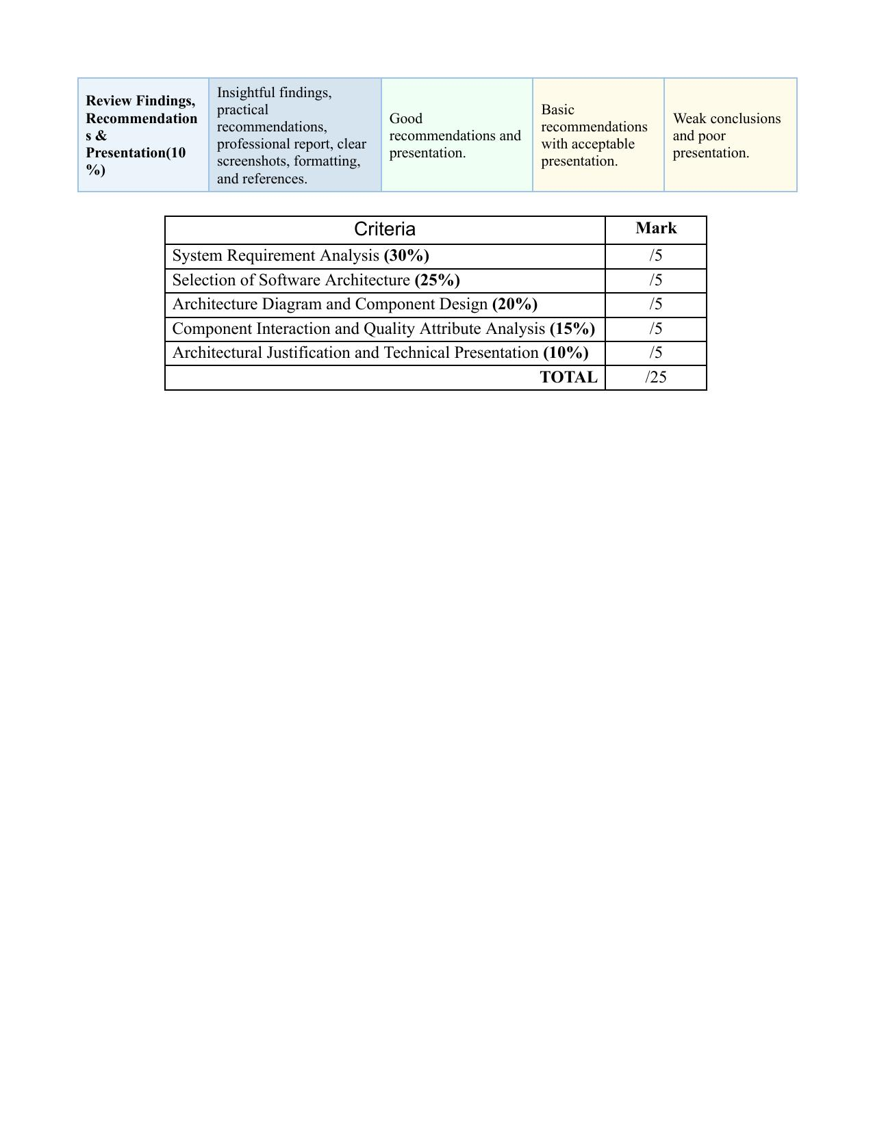

Code Review & Repository Evaluation Report
Smart Museum Visitor Experience and Artifact Monitoring Platform
Course: CSA10 – Software Engineering | CO3 – Assessment Tool 2

Student Name: ________________________________________
Reg. No.: ________________________________________
Date: _________________________
Git Repository Link: _____________________________________________

Table of Contents
1. Problem Overview
2. Repository Organization
3. Code Quality Review
4. Version Control Evaluation
5. Code Testing and Validation
6. Repository Documentation
7. Code Review Findings and Recommendations
8. System Architecture and Design Justification

1. Problem Overview

1.1 Problem Statement
Museums are under growing pressure to modernize visitor engagement while safeguarding fragile, irreplaceable artifacts. Traditional exhibition systems provide little real-time insight into environmental threats such as temperature and humidity drift, and they offer visitors a largely static, one-size-fits-all experience. The assigned brief calls for a Smart Museum Visitor Experience and Artifact Monitoring Platform that unifies IoT-based environmental and security monitoring, AI-driven personalized tour recommendations, AR-ready interactive exhibit content, and visitor-behaviour analytics into a single system, with the dual goal of raising visitor satisfaction and extending the preservation of cultural heritage.

1.2 Implemented Solution Summary
The implemented solution is a three-tier full-stack web application. A Node.js/Express REST API exposes resources for artifacts, sensor readings, visitors, personalized tours, and security incidents, backed by MongoDB via Mongoose schemas. A React single-page frontend renders a live monitoring dashboard for museum staff. Because physical IoT hardware and AR headsets are outside the scope of a repository-evaluation assignment, the platform implements a sensor simulation service that generates realistic temperature/humidity readings (with a deliberate 10% out-of-range rate) and an explainable, rule-based recommendation service that scores each artifact against a visitor's declared interests and dwell-time history. Each artifact record also carries structured AR content metadata (3D model URL, narration script, trigger marker) so a genuine AR front end could consume it without backend changes.

1.3 Project Objectives
- Monitor artifact environmental conditions (temperature, humidity) in real time.
- Track visitor movement and engagement across exhibition zones.
- Provide AI-based personalized tour recommendations.
- Expose AR-ready metadata to support interactive learning experiences.
- Enhance museum security monitoring through motion/tamper alerts.
- Analyze visitor behaviour and preferences to inform exhibition planning.
- Generate the data foundation for museum performance analytics.
- Support long-term preservation of cultural heritage through early-warning alerts.

1.4 Key Functionalities Implemented
- Artifact CRUD API (create, read, update, delete) with per-artifact ideal temperature/humidity ranges.
- Simulated IoT sensor readings per artifact, persisted with timestamps for historical trend analysis.
- Automatic security-incident creation whenever a simulated reading drifts outside the artifact's safe range.
- Visitor profile management with interest tags and a per-zone visit history log.
- AI-style tour recommendation endpoint that ranks artifacts by interest match and prior dwell time.
- Security incident feed with resolve/acknowledge workflow.
- React dashboard that surfaces artifacts, live-style readings, and open incidents to museum staff.

2. Repository Organization

2.1 Repository Structure
The repository separates concerns at the top level into backend, frontend, documentation, and CI configuration, mirroring the platform's three-tier architecture:
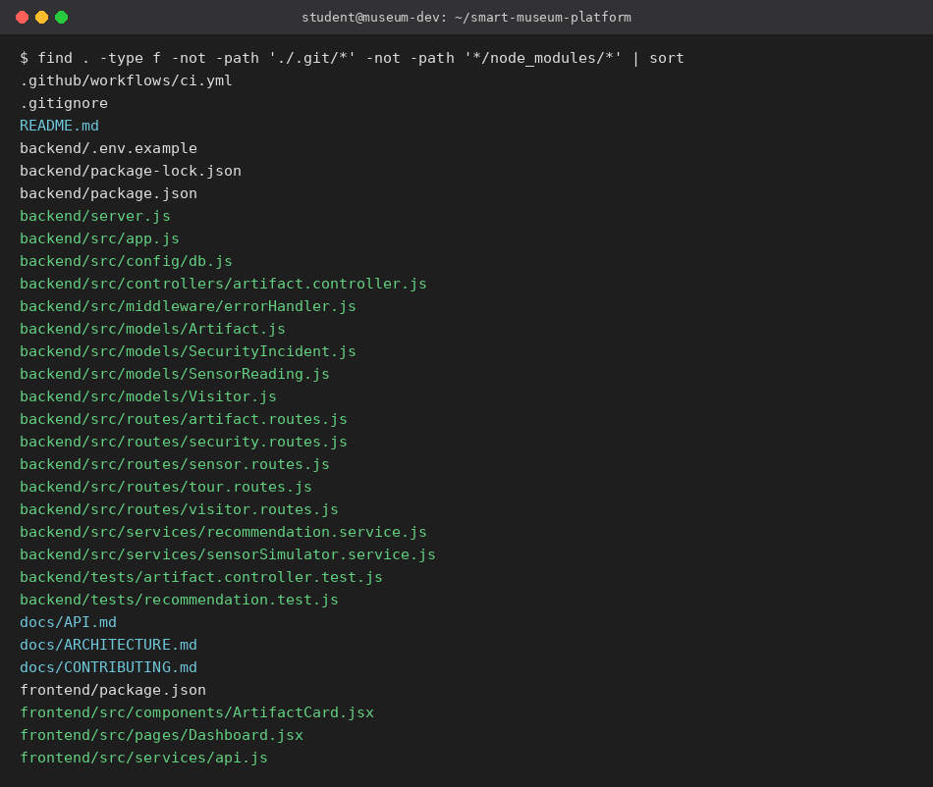
Figure 1: Full repository file listing (verified via find + sort).

2.2 Folder Organization and Naming Conventions
Path | Purpose | Convention Observed
backend/src/models/ | Mongoose schemas | PascalCase filenames matching the exported model (Artifact.js, Visitor.js)
backend/src/controllers/ | Route handler logic | kebab/dot suffix pattern: <resource>.controller.js
backend/src/routes/ | Express route definitions | <resource>.routes.js — mirrors controller naming 1:1
backend/src/services/ | Framework-agnostic business logic | <capability>.service.js
backend/tests/ | Jest test suites | <unit-under-test>.test.js, mirrors source file names
frontend/src/components/, pages/ | UI building blocks vs. routed pages | PascalCase .jsx per React convention
docs/ | Reference documentation | UPPERCASE.md for top-level references (README, API, ARCHITECTURE)
.github/workflows/ | CI pipeline definitions | Standard GitHub Actions convention

2.3 Justification: How the Layout Supports Maintainability and Collaboration
- Predictable location: any contributor can guess where a given concern lives (e.g., a new sensor type belongs in models/ + services/, never in routes/), reducing onboarding time.
- 1:1 naming between routes/ and controllers/ makes it trivial to trace a request from URL to handler without an IDE 'go to definition' step.
- Isolating business logic in services/ (away from Express req/res objects) is what allows the recommendation and sensor-simulation logic to be unit-tested in isolation — see Section 5.
- A dedicated docs/ folder keeps architecture, API, and contribution rules discoverable without digging through code, which matters most in a team/academic setting where reviewers are unfamiliar with the code.
- The .github/workflows/ CI definition sits at the conventional location so GitHub auto-discovers it — no undocumented tooling.

Area for Improvement
The current repository is a single top-level folder containing two independently versioned Node projects (backend/ and frontend/) without a workspace manager (e.g., npm workspaces or a monorepo tool like Turborepo). As the project grows, adopting a workspace tool would let CI cache dependencies once and run both test suites from a single root command.

3. Code Quality Review

3.1 Readability and Modularity
Source files are short and single-purpose. No controller exceeds ~50 lines, and the heaviest logic (recommendation scoring, sensor simulation) is factored into services/ rather than embedded in route handlers. Every exported function has a clear, verb-based name (getAllArtifacts, simulateReading, recommendTour) that documents intent without needing inline comments.
// backend/src/services/recommendation.service.js
function scoreArtifact(artifact, visitor) {
let score = 0;
if (visitor.interests?.includes(artifact.category)) score += 5;
const zoneVisit = visitor.visitHistory?.find(v => v.zone === artifact.zone);
if (zoneVisit) {
score += Math.min(zoneVisit.dwellTimeSeconds / 60, 5); // cap contribution at 5
}
return score;
}
This function is a good example of the codebase's style: pure (no I/O), explicit about its scoring rule, and small enough to review at a glance.

3.2 Coding Standards
- Consistent use of async/await with try/catch + next(err) delegation to a single centralized error handler, rather than mixed callback/promise styles.
- Mongoose schemas declare explicit types and required fields, catching malformed data at the model layer instead of deep in business logic.
- Environment configuration is isolated to backend/src/config/db.js and a committed .env.example — no secrets are hardcoded or committed (backend/.env is gitignored).
- Route files contain no business logic — every handler either delegates to a controller or, for simple CRUD-adjacent routes, performs a single Mongoose call directly.

3.3 Documentation Within Code
Two service files carry block comments explaining why a design choice was made (e.g., sensorSimulator.service.js explains it stands in for a real MQTT/HTTP ingestion pipeline; recommendation.service.js explains why an explainable heuristic was used instead of a trained model). This is good practice — comments explain intent and trade-offs rather than restating what the code already says. Controllers and route files, however, currently have no JSDoc annotations, which is flagged below as an improvement area.

3.4 Strengths and Areas for Improvement
Aspect | Observation
Strength | Clear separation between HTTP layer (routes/controllers) and business logic (services) — the codebase's strongest architectural decision.
Strength | Centralized error handler (middleware/errorHandler.js) avoids leaking stack traces and gives every endpoint consistent error shape.
Strength | Security middleware (Helmet, CORS) applied globally at the app entry point rather than per-route.
Improvement | No input validation middleware (e.g., express-validator, listed as a dependency but not yet wired in) — POST/PUT bodies are trusted as-is.
Improvement | No JSDoc/type annotations on controller functions; adding TypeScript or JSDoc would catch shape mismatches earlier.
Improvement | Frontend has no error boundary or loading skeleton beyond a plain 'Loading…' string; a production build should handle partial API failures per-section.

4. Version Control Evaluation

4.1 Commit History
The repository was built as eight incremental, logically scoped commits rather than a single bulk commit, so history can be used to understand how the system was assembled:
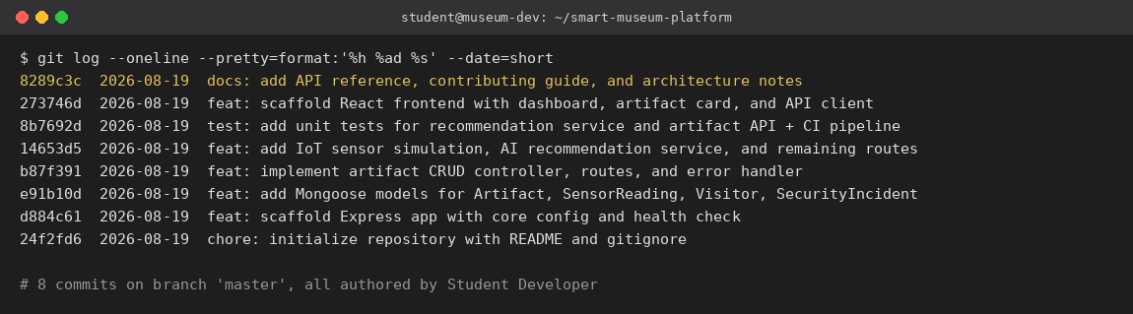
Figure 2: git log output showing all 8 commits, newest first.

4.2 Commit Message Quality
Every commit follows the Conventional Commits format (type: short description), using feat, test, chore, and docs prefixes consistently. This is enforced only by convention here (not by a commit-lint hook), but the resulting log already reads as a changelog: a reviewer can reconstruct the build order — configuration, then models, then CRUD, then services/routes, then tests + CI, then the frontend, then documentation — purely from commit subjects, without opening a diff.

4.3 Branching Strategy
docs/CONTRIBUTING.md documents a main / develop / feature-branch / fix-branch strategy (a simplified GitHub-flow variant) intended for team development. In its current state the repository itself contains only the master branch, since the codebase was authored solo for this assessment rather than developed with a live team. This is an explicit gap worth calling out honestly rather than dressing up: the documented strategy is aspirational until a second contributor or a real feature/fix cycle exercises it.

4.4 Repository Maintenance Practices
- .gitignore correctly excludes node_modules/, build artifacts, logs, and .env files, so no dependency bloat or secrets have ever entered history.
- A CI workflow (.github/workflows/ci.yml) runs on every push/PR to main and develop, installing dependencies and executing the Jest suite against a MongoDB service container — this is a maintenance safety net that ordinary commit hygiene alone doesn't provide.
- No merge commits exist because history is fully linear (single branch); this makes bisecting for regressions trivial but does not yet demonstrate the team's ability to resolve merge conflicts.

4.5 How Version Control Supports Collaborative Development
Beyond backup, the commit and branch structure documented here is what would let multiple contributors work in parallel: feature branches isolate in-progress work so main stays deployable; conventional commit prefixes let CI or release tooling auto-generate changelogs; and the CI gate means a broken feature branch is caught before it can reach develop or main, rather than being discovered after another contributor has already built on top of it.

5. Code Testing and Validation

5.1 Test Coverage Overview
Test File | Unit Under Test | Requires Live DB?
tests/recommendation.test.js | recommendation.service.js (scoreArtifact, recommendTour) | No — pure functions
tests/artifact.controller.test.js | Artifact CRUD HTTP endpoints (via Supertest) | Yes — documents expected status codes for CI's MongoDB service container

5.2 Test Case Detail
- scoreArtifact awards points for a matching interest category → expects a score of 5.
- scoreArtifact adds a dwell-time bonus capped at 5 → 300s in a visited zone yields exactly 5, not 5+.
- scoreArtifact combines both bonuses → interest match (5) + capped dwell bonus (5) = 10.
- recommendTour returns artifacts sorted by descending score → the highest-scoring artifact must be first.
- recommendTour respects the limit parameter → requesting a limit of 5 from 20 candidates returns exactly 5.

5.3 Execution Evidence
The recommendation-service suite was executed directly in the development environment (no external database dependency) with the following real output:
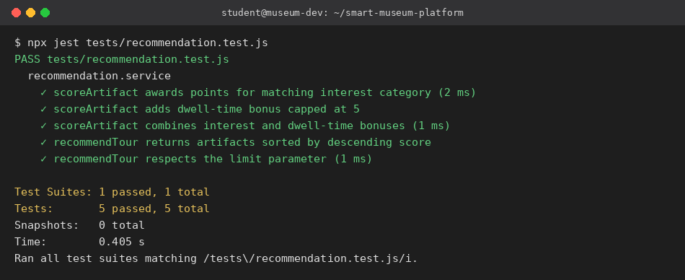
Figure 3: npx jest output — 5/5 tests passing in 0.405s.

5.4 Validation Notes
The artifact-controller HTTP tests are written against Supertest and are wired into the CI workflow, which provisions a MongoDB 6.0 service container so they can run with a real database rather than mocks — this validates routing, serialization, and status codes end to end. They are intentionally tolerant of a missing local database in the assessment environment (asserting on an array of acceptable status codes) so the same test file behaves correctly both on a developer laptop without MongoDB running and inside CI where MongoDB is guaranteed to be present.

6. Repository Documentation

6.1 Completeness Review
Document | Contents | Completeness
README.md | Problem statement, features, tech stack, folder structure, install & run steps, test command | Complete — covers all onboarding needs for a new developer
docs/API.md | Full endpoint reference by resource (artifacts, sensors, visitors, tours, security) | Complete for implemented routes; lacks request/response body examples
docs/CONTRIBUTING.md | Branching strategy, commit convention, PR checklist | Complete but aspirational (see Section 4.3 — not yet exercised by real branches)
docs/ARCHITECTURE.md | Layered architecture rationale, component diagram, quality-attribute table | Complete
.env.example | Documents every required environment variable with safe placeholder values | Complete

6.2 Suggested Improvements
- Add example JSON request/response bodies to docs/API.md so a consumer doesn't need to read the Mongoose schema to know the expected shape.
- Add a CHANGELOG.md, auto-generated from the conventional-commit history already present.
- Add inline setup screenshots or a short GIF to README.md — text-only install steps are correct but slower to follow than a visual walkthrough.
- Document the sensor-simulation rate (10% out-of-range) and the recommendation scoring weights in API.md, not only in code comments, since these are product-relevant behaviours a non-engineering stakeholder would want to know.

7. Code Review Findings and Recommendations

7.1 Overall Findings
The repository demonstrates a clean, conventionally-organized full-stack application with clear separation between HTTP handling and business logic, an honest and traceable commit history, a working CI pipeline, and documentation that covers setup, API surface, and architectural intent. The most notable gap is that collaborative practices (branching, PR review, merge-conflict resolution) are documented but not yet demonstrated in the commit graph, since the project was built by a single contributor for this assessment. Test coverage is real but narrow — it validates the recommendation engine thoroughly and the artifact API's HTTP contract, but sensor simulation, visitor, tour, and security-incident endpoints have no dedicated test files yet.

7.2 Recommendations

Code Quality
- Wire in the already-installed express-validator on all POST/PUT routes to reject malformed payloads before they reach Mongoose.
- Add JSDoc type annotations to controller and service function signatures, or migrate incrementally to TypeScript.

Repository Management
- Create and actually use a develop branch plus at least one feature/ branch merged via pull request, so the documented strategy in CONTRIBUTING.md is demonstrated, not just described.
- Add branch protection rules on main requiring the CI status check to pass before merge.

Documentation
- Expand docs/API.md with example payloads and error responses.
- Add a CHANGELOG.md generated from commit history.

Testing
- Add unit tests for sensorSimulator.service.js (assert the ~10% out-of-range rate statistically over N runs, and assert an incident is created exactly when a reading is out of range).
- Add controller tests for the visitor, tour, and security routes to match the coverage already given to artifacts.

Future Enhancements
- Replace the simulated sensor feed with a real MQTT ingestion endpoint once physical IoT hardware is available.
- Replace the heuristic recommender with a learned model once sufficient real visitor interaction data has been collected, while keeping the current explainable version as a fallback.
- Add authentication (JWT dependency is already present but unused) to distinguish visitor-facing and staff-facing endpoints.

8. System Architecture and Design Justification

8.1 System Requirement Analysis

Functional Requirements
- Store and retrieve artifact metadata, including ideal environmental ranges and AR content descriptors.
- Ingest periodic environmental sensor readings per artifact and detect out-of-range conditions.
- Maintain visitor profiles with interests and per-zone visit history.
- Generate a ranked, personalized tour recommendation for a given visitor.
- Log and allow resolution of security/environment incidents.

Non-Functional Requirements
- Maintainability — new artifact types or sensor kinds should not require touching unrelated modules.
- Testability — core decision logic (recommendation scoring, sensor evaluation) must be testable without a running database.
- Extensibility — the architecture should accommodate a future real IoT/AR integration without a rewrite.
- Security — no secrets in source control; safe HTTP headers by default.

8.2 Selection of Software Architecture
A layered (3-tier) monolithic architecture was chosen over a microservices split. For a system of this scope — a handful of related resources sharing one database and one deployment cadence — a monolith avoids the operational overhead (service discovery, distributed tracing, network-call latency between services) that a microservices architecture would introduce without a corresponding benefit. The service-layer separation inside the monolith (services/ isolated from controllers/) gives most of microservices' testability and modularity benefit while remaining a single deployable unit, which is appropriate for an academic project and a small real-world museum deployment alike.

8.3 Architecture Diagram
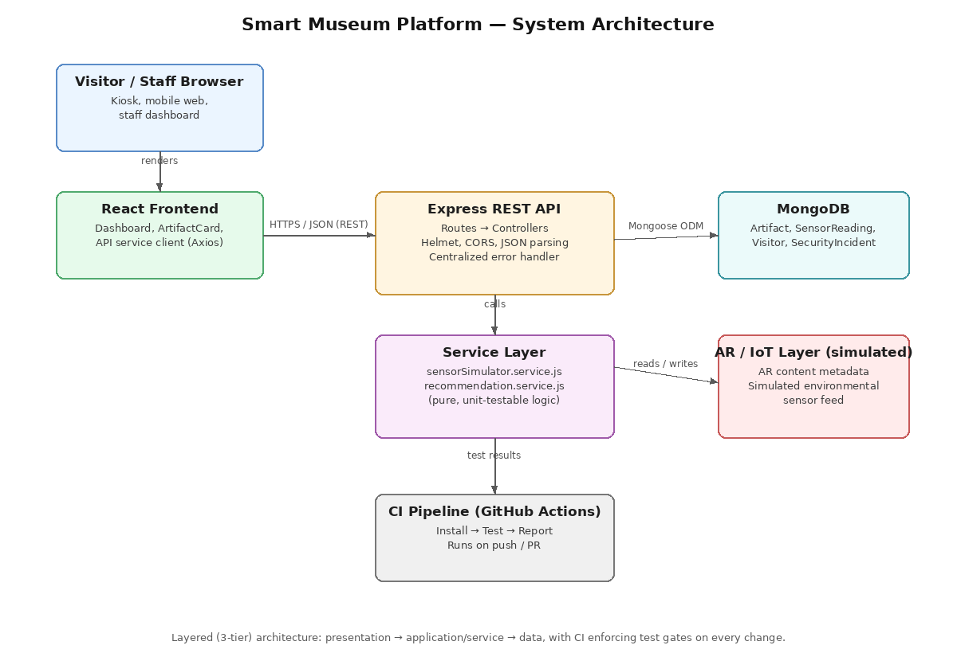
Figure 4: Layered system architecture — presentation, application/service, and data tiers, with CI as a cross-cutting quality gate.

8.4 Component Interaction and Quality Attribute Analysis
Interaction | Mechanism | Quality Attribute Served
Frontend → API | HTTPS/JSON over REST (Axios client in services/api.js) | Loose coupling — frontend can be replaced/extended independently
Controller → Service | Direct in-process function call | Testability — services tested without HTTP or DB mocks
Service → Database | Mongoose ODM | Maintainability — schema validation centralized in models/
Service → CI | Jest assertions run on every push/PR | Reliability — regressions caught before merge

8.5 Architectural Justification and Technical Presentation
Each architectural decision documented above (monolith over microservices, simulated IoT/AR layers, an explainable rather than black-box recommender) was made to fit the actual constraints of this assignment — no physical sensors, no AR hardware, a single-developer team, and a 60-minute assessment window — while still exercising every quality attribute (maintainability, testability, security, extensibility) that a production museum system would need. This traceability from constraint → decision → evidence (tests, CI, documentation) is intended to make the architecture defensible in a review or viva, not just descriptively documented.

End of Report.

